1: What is the primary purpose of using a dictionary in a Snake and Ladder game?

A) To store the players' names

B) To keep track of dice rolls

C) To map snakes and ladders to their destination positions

D) To store winning scores

Answer: C

2: What is the usual winning condition in a Snake and Ladder game?

A) When a player rolls a 6

B) When a player reaches exactly position 100

C) When a player crosses position 90

D) When a player has 10 turns

Answer: B

3: What does this code block do?

if position in snakes:

position = snakes[position]

A) It increases the player's score

B) It moves the player forward

C) It checks if the player hit a snake and moves them to the tail

D) It ends the game

Answer: C

4: Which module must be imported to simulate dice rolling in Python?

A) math

B) time

C) random

D) sys

Answer: C

5: Which of the following is the best way to represent ladders in the game?

A) A list of numbers

B) A set of values

C) A dictionary with bottom as key and top as value

D) A tuple of tuples

Answer: C

6: Why is it important to check if position <= 100 before updating a player's position?

A) To avoid errors in the dictionary

B) To skip player turns

C) Because the board ends at position 100 and player must not overshoot

D) To stop the snake from working

Answer: C

7: What is the role of input() in a two-player Python Snake and Ladder game?

A) To randomize ladder positions

B) To pause and wait for user action before rolling the dice

C) To calculate player scores

D) To store snake positions

Answer: B

8.How are dice rolls implemented in the game?

A) Using a fixed sequence of numbers

B) Using random.randint(1,6)

C) User inputs the dice value

D) Using a dice simulation function

Answer: B)

9. Which function is used to check if a player has landed on a ladder?

A) ladder_check()

B) check_ladder()

C) is_ladder()

D) find_ladder()

Answer: B)

10.What is recursion in Python?

A. A way to loop indefinitely

B. A function calling itself

C. A function calling another function

D. Repeating code using while loop

Answer: B.

11. Which of the following is true about recursion?

a. Every recursive function must contain a loop

b. Recursive functions are always faster than iterative solutions

c. Every recursive function must include a base case

d. Recursion can only be used for mathematical operations

**ANS-c)**

12.Which Python package would be most appropriate for implementing complex network analysis?

A) SciKit-Learn

B) NetworkX

C) Beautiful Soup

D) Seaborn

Ans : b

13.In graph visualization libraries, which method typically renders the network diagram?

A) render()

B) visualize()

C) draw()

D) display_graph()

Ans : c

14.When importing network data from text files, which function parses connection information properly?

A) import_connections()

B) read_edgelist()

C) parse_network()

D) load_graph_data()

Ans : b

15.What data structure provides the most efficient key-value mapping for storing node attributes?

A) Nested lists

B) Array matrix

C) Dictionary

D) Tuple set

Ans : c

16.Which algorithm revolutionized web search by analyzing link structures?

A) Hierarchical clustering

B) Neural embedding

C) PageRank

D) Decision tree

Ans : c

17.When displaying networks with thousands of nodes, which parameter ensures identity visibility?

A) node_identifiers=True

B) show_ids=True

C) with_labels=True

D) display_names=True

Ans : c

18.How are ranking results typically arranged for analysis in data science?

A) Using descending sort functions

B) Using hierarchical clustering

C) Using pivot tables

D) Using dimensional reduction

Ans : a

19. Which principle does the Tower of Hanoi problem illustrate?

a) Divide and conquer

b) Greedy algorithm

c) Dynamic programming

d) Backtracking

Answer: a

20.PageRank algorithm is primarily used to:

a) Sort numbers in ascending order

b) Rank web pages based on their importance

c) Encrypt data

d) Compress images

Answer: b

21.PageRank considers a web page important if:

a) It has many outbound links

b) It has many inbound links from important pages

c) It has a large file size

d) It loads faster

Answer: b

22. Which of the following is NOT a characteristic of recursion?

a) Base case

b) Recursive call

c) Infinite loop

d) Stack usage

Answer: c

23.Which of the following is true for the Tower of Hanoi problem?

a) Only one disk can be moved at a time

b) A larger disk can be placed on a smaller disk

c) Disks can be moved between any two rods without restriction

d) The problem has no recursive solution

Answer: a

24. Which of the following is the best locator strategy in Selenium in terms of performance?

a. find_element_by_name()

b. find_element_by_id()

c. find_element_by_class_name()

d.find_element_by_xpath()

ans : b

25. What does calendar.isleap(2100) return?

a.False

b.True

c.None

d.1

Ans : a

26.What happens when you apply .astimezone() to a naive datetime object?

a.It changes to UTC

b.It raises an error

c. It assumes local timezone

d.It converts to IST

ans : C

27.What is the output of datetime.date(2024, 2, 29) + datetime.timedelta(days=1)?

a. 2024-02-30

b.2024-03-01

c.ValueError

d. 2024-02-29

ans : b

28.Which function is used to get the current local time in Python?

a.time.localtime()

b.datetime.now()

c.time.time()

d.datetime.utcnow()

ans : b

29.In networkX, which function is used to return the degree of a specific node?

a.G.degree(node)

b.G.get_degree(node)

c.G.node_degree(node)

d. G.find_degree(node)

Ans :a

30.What is the output of the following Python code?

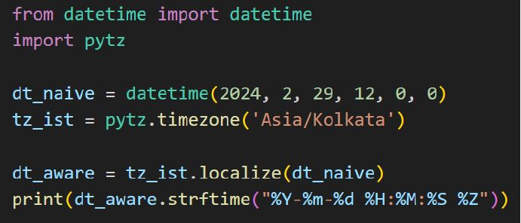

a.2024-02-29 12:00:00 IST

b.2024-02-29 06:30:00 UTC

c.2024-02-29 12:00:00 UTC

d. Error

ans : a

31. What does nx.cycle graph(4) generate?

a.A directed cycle of 4 nodes

b.A cycle graph with 4 nodes connected in a closed loop

c.A ladder graph with 4 rounds in the ladder

d.A complete graph with 4 nodes

Ans : b

32. What will be the output of the following code?

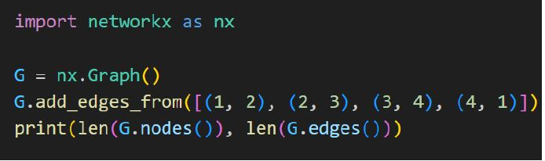

a. (4, 4)

b. (4, 8)

c. (4, 2)

d. (8, 4)

ans : a

33. What will be the first 10 numbers generated starting from n = 7?

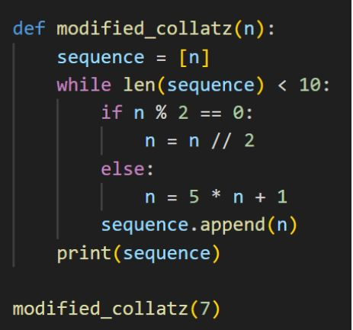

a.[7, 36, 18, 9, 46, 23, 116, 58, 29, 146]

b.[7, 36, 18, 9, 28, 14, 7, 36, 18, 9]

c.[7, 20, 10, 5, 26, 13, 66, 33, 166, 83]

d.[7, 31, 15, 7, 36, 18, 9, 46, 23, 116]

ans : a

34. In the PageRank algorithm, what happens when a page receives multiple inbound links from highly ranked pages?

a.Its rank decreases due to increased server load

b.Its rank improves

c.Its rank remains the same

d.It is considered less relevant

ans : b

35. Observe the following graph generated using the networkx module. How many edges does this graph contain?

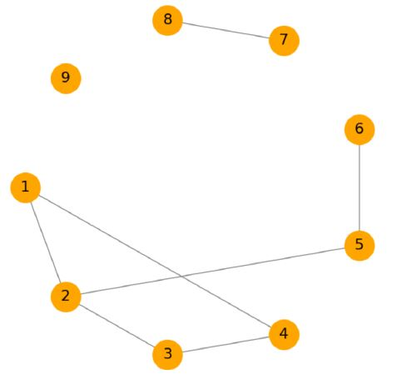

a.6

b.7

c.8

d. 9

ans : b